SIT708 Task 2.1P
- LLM Declaration Statement

- For this first project Task 2.1P, I have used a chat LLM to assist me with this task. Below are the parts that were influenced by LLM.

- Steps for currency conversion – I needed clarification on how the currency conversion works. So, I had to prompt 3 different LLMs for the first part of the task. That helped me to complete the currency conversion part.
- @SuppressLint({"SetTextI18n", "DefaultLocale"})
private void convert() {
String input = currencyAmount.getText().toString().trim();
TextView currencyResult = findViewById(R.id.currencyResult);
if (input.isEmpty()) {
Toast.makeText(this, "Enter Amount", Toast.LENGTH_SHORT).show();
return;
}
double amount;
try {
amount = Double.parseDouble(input);
} catch (NumberFormatException e) {
currencyResult.setText("Invalid number");
return;
}
String fromCurrency = convertFrom.getSelectedItem().toString();
String toCurrency = convertTo.getSelectedItem().toString();
double rateFrom = getCurrencyRate(fromCurrency);
double rateTo = getCurrencyRate(toCurrency);
//does the conversion
double result = amount * (rateTo / rateFrom);
currencyResult.setText(String.format("%.2f %s", result, toCurrency));
}
private double getCurrencyRate(String currency) {
// conversion rates (base = USD)
double USD = 1.0, EUR = 0.92, GBP = 0.78,
AUD = 1.55, JPY = 148.50;
switch (currency) {
case "USD":
return USD;
case "EUR":
return EUR;
case "GBP":
return GBP;
case "AUD":
return AUD;
case "JPY":
return JPY;
default: return 1.0;
}
}

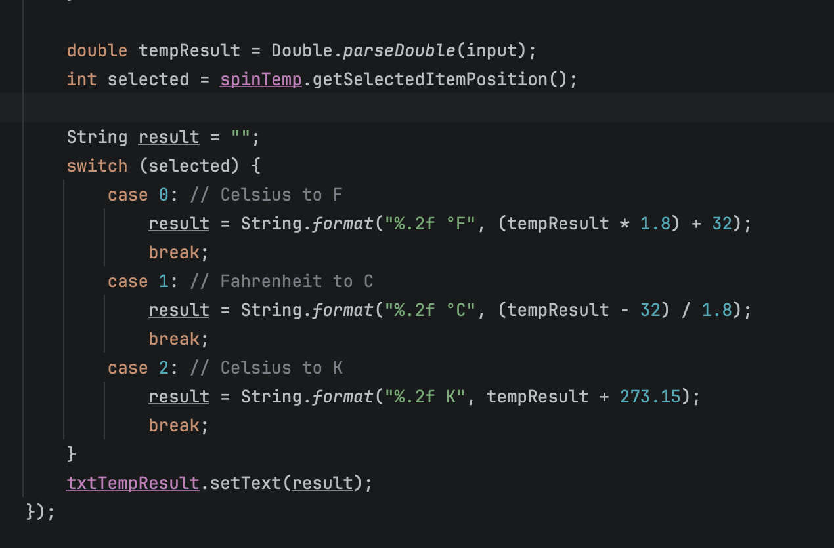
- Fuel and & Distance conversion – I was confused on that part on how to do the proper mathematical calculation. I got the idea to implement the below switch conditional statement.

- Subtask 3: Gemini Nano Research Report (500 Words)

The rise of large language models (LLM) in computing technological advancement has a direct impact on edge computing particularly in mobile apps development [1]. This short study will explore and discuss five use cases for Google’s Gemini AI.

To begin with, Gemini’s standalone interaction mode for mobile device has an interaction user interface with Gemini. Contrastingly, Gemini’s has its workspace integrated contextual AI assistance across Google’s workspace apps Gmail, google docs, google drive, meet, sheets and slides [2]. For instance, Google Meet embedded its AI into it for real-time translations and transcripts for more that 65 languages. According to [3], tests were carried to explore the best LLM model performance from the three models, Google translate, Gemini and ChatGPT. Gemini outperformed the other two models for least errors with the translation of research titles in Arabic into English. Hence, integrating Gemini for translations and transcripts in mobile app will leverage user experience.

Content generation is another common and popular function of Gemini to generate contents from user prompts. The popularity and ability of LLMs functionality to generate contents have become crucial in all works of life. Gemini’s text content creation has leveraged users experience with the best text creation. Apps like Gmail, Google Docs and Meet have been exceptional in that regard accordingly [2]. The ability to correct grammar, spelling errors and text structure has become is a valuable tool that engages and supports students in their academic performance [4].

The multimedia generation is another functionality of Gemini to generate any multimedia content by users’ specification prompts. Creating images, videos and music for users’ need has been a great demand for quick content creation. According to [2], such functionalities may not yet available at the time of writing, such as images and music content generation. However, with the recent development of Gemini, images and music is already available [5]. Video content generation may become available soon.

Data entry with processing is another functionality that makes essential repetitive tasks easier with automation. For instance, capabilities like multi-modal made it possible for automation and processing of data that is unstructured [2]. Workers utilize Gemini to extract details such as images and screenshots from invoices which eliminates the need for manual entry of data. Additionally, solution engineers were able to extract XML codes submitted from clients’ screenshots which accelerates troubleshooting process.

Coding assistance and technical automation has also become a great demand that leverages workers understanding and ability to tackle complex and challenging problems. Workers can extend their technical skills like IT professionals to learn new skills and sharpen their knowledge. They can generate and debug code, experiencing and learning the vast programming languages [2]. The integration of Gemini to mobile apps locally has seen a bright future to leverage the benefits from the ever-growing functionalities and features.

According to [6], modern smart phones have the computational power and capability to integrate LLM to process intensive computation. The enhanced user experience like voice assistance, natural language understanding, real-time and translation with personalized recommendation are some of the popular functions and features users enjoy most.

- YouTube Demonstration Video Link

- Here’s the YouTube link: https://youtu.be/iETTAMBYEag

- GitHub Repository Link

- Here’s the link: https://github.com/225221834/SIT708

- LLM Conversation Link (If Applicable)

- LLM prompt links

- For Fuel efficiency clarification: https://copilot.microsoft.com/shares/YaCW72ahiEdiroqGuYCUp

- For currency calculation steps, same question was asked for 3 different LLM below. Once I get more clarification for the first part of the task. I was able to complete the other part of the tasks.
https://copilot.microsoft.com/shares/ZPs2YGHCkSWhhV4w8N5Vu

https://chatgpt.com/s/t_69c3faa50e848191a647cffe410174d5

https://grok.com/share/c2hhcmQtMw_ffece7e7-06f2-45b1-af2d-d5c502cdf1cb

- Online site: https://developer.android.com/develop/ui/views/components/spinner#java

References

[1] D. Rosario, “Gemini Nano Guide: Implementing On-Device SLMs in Android 16,” Medium. Accessed: Mar. 26, 2026. [Online]. Available: https://medium.muz.li/gemini-nano-guide-implementing-on-device-slms-in-android-16-54b9dab41811

[2] N. Sun and D. Kalar, “Gemini at Work: Knowledge Workers’ Perceptions and Assessment of Productivity Gains,” in Proceedings of the 2025 ACM Designing Interactive Systems Conference, Madeira Portugal: ACM, Jul. 2025, pp. 3681–3695. doi: 10.1145/3715336.3735679.

[3] M. Farghal and A. S. Haider, “Translating classical Arabic verse: human translation vs. AI large language models (Gemini and ChatGPT),” Cogent Social Sciences, vol. 10, no. 1, p. 2410998, Dec. 2024, doi: 10.1080/23311886.2024.2410998.

[4] M. L. Ng, B. Behforouz, and A. A. Ghaithi, “Grammar and engagement in focus: Evaluating Gemini AI’s impact on an educational environment,” Computers and Education Open, vol. 9, p. 100302, Dec. 2025, doi: 10.1016/j.caeo.2025.100302.

[5] “‎Google Gemini,” Gemini. Accessed: Mar. 26, 2026. [Online]. Available: https://gemini.google.com

[6] L. Wu, Y. Zhao, C. Wang, T. Liu, and H. Wang, “A First Look at LLM-powered Smartphones,” in Proceedings of the 39th IEEE/ACM International Conference on Automated Software Engineering Workshops, Sacramento CA USA: ACM, Oct. 2024, pp. 208–217. doi: 10.1145/3691621.3694952.

